* **RHYTHMIC TUNES**
* “A TUNE BECOMES TIMELESS WHEN RHTYM MEETS EMOTION”

**SUBMITTED BY:**

* **PRIYA S**
* **SANJINI R**
* **SHARMILA K**
* **ROJA R**

**II BSC CS ‘B’**

**SHRI SHANKARLAL SUNDARBAI SHASUN JAIN COLLEGE FOR WOMENS CHENNAI -17**

**Team leader:**

**Priya S–** [**priyasumathi1979@gmail.com**](mailto:priyasumathi1979@gmail.com)

**Team Members:**

**Sharmila K–** [**sharmilakamaraj006@gmail.com**](mailto:sharmilakamaraj006@gmail.com)

**Roja R –** [**rojararamesh567@gmail.com**](mailto:rojararamesh567@gmail.com)

**Sanjini R –** [**sanjinirajendrean@gmail.com**](mailto:sanjinirajendrean@gmail.com)

**INTRODUCTION:**

**Music is a universal language, and rhythm is the pulse that gives it life. Rhythmic Tunes is a project that explores how beats, patterns, and timing create energy, structure, and emotion in music. Rhythm provides the foundation for melodies and harmonies, guiding tempo and movement while connecting listeners through a shared sense of timing. Whether in classical compositions, folk traditions, or modern pop and electronic genres, rhythm shapes the character of every tune and sets the mood for audiences worldwide.**

**This project focuses on studying various rhythmic elements such as tempo, meter, and time signatures, along with their cultural and historical significance. It highlight how different musical traditions—ranging from Indian classical tala cycles to African drum patterns and Western jazz syncopation—demonstrate the diversity and richness of rhythmic expression. The research also examines how rhythm affects human emotions and physical responses, showing its ability to influence mood, inspire dance, and strengthen social bonds.**

**By combining analysis, listening exercises, and creative experimentation, Rhythmic Tunes aims to showcase rhythm as more than just background support. It is the heartbeat of music, a force that drives creativity, unites people across cultures, and makes every musical experience vibrant and unforgettable.**

**Rhythmic Tunes is a front-end music-streaming web application crafted with React.js, Vite, CSS, and Bootstrap.**

**It enables listeners to play songs, browse by performer/genre/title, mark favorites, and create custom mixes through a clean, intuitive design.**

**Component Hierarchy**

**App.jsx: Core component that manages routing.**

**Navbar / Sidebar: Handles navigation (All Songs, Favorites, Playlists).**

**Songs Module: Shows all tracks from db.json.**

**Favorites Module: Displays the user’s liked tracks.**

**Playlist Module: Presents custom song lists.**

**Player Module: Audio console with play/pause controls.**

**SearchBar: Filters tracks by artist, style, or title.**

**State Handling**

**Local: Managed with useState for search text, active track, and form updates.**

**Data: Synced with db.json using Axios and useEffect.**

**props drilling is used for passing data globally.**

**Routing Paths**

**/ → Songs**

**/favorites → Favorites**

**/playlist → Playlist**

**Music enthusiasts often struggle with:**

**Organizing extensive track libraries**

**Limited playlist flexibility in basic apps**

**Interfaces that discourage regular use**

**Rhythmic Tunes counters these issues with a lightweight, easy-to-navigate music companion featuring personalized mixes, favorites, and seamless playback.**

**Goals**

**Intuitive Design: Let users browse, save, and sha**

**re music effortlessly.**

**Robust Streaming: Manage songs with advanced lookup options.**

**Modern Stack: Built with React.js, Vite, and Tailwind CSS for speed and efficiency.**

**Scope**

**Comprehensive song archive with metadata (title, performer, style, cover art, audio URL)**

**Advanced search by song name, genre, or artist**

**Playlist creation and management**

**Favorites (wish-list) feature**

**One-track-at-a-time audio control**

**Hardware**

**CPU: Intel i3 or higher (i5 suggested)**

**RAM: 4 GB minimum (8 GB recommended)**

**Storage: 10 GB free**

**Display: 1366×768 or above**

**Software**

**OS: Windows 10/11, macOS, or Linux**

**Languages: JavaScript (ES6+), JSX, HTML, CSS**

**Framework: React.js (v18.2.0)**

**Styling: Tailwind CSS & Bootstrap**

**Build Tool: Vite**

**Version Control: Git & GitHub**

**Package Manager: npm**

**Browser: Chrome, Firefox, or Edge**

**Testing confirmed:**

**Accurate song retrieval**

**Instant favorite/unfavorite updates**

**Persistent playlist management**

**Reliable search filtering**

**Single-track audio playback**

**Smooth performance across desktop and mobile**

**Output Pages:**

**Songs Library, Favorites, Playlist, Now Playing**

**Screenshot of the coding**

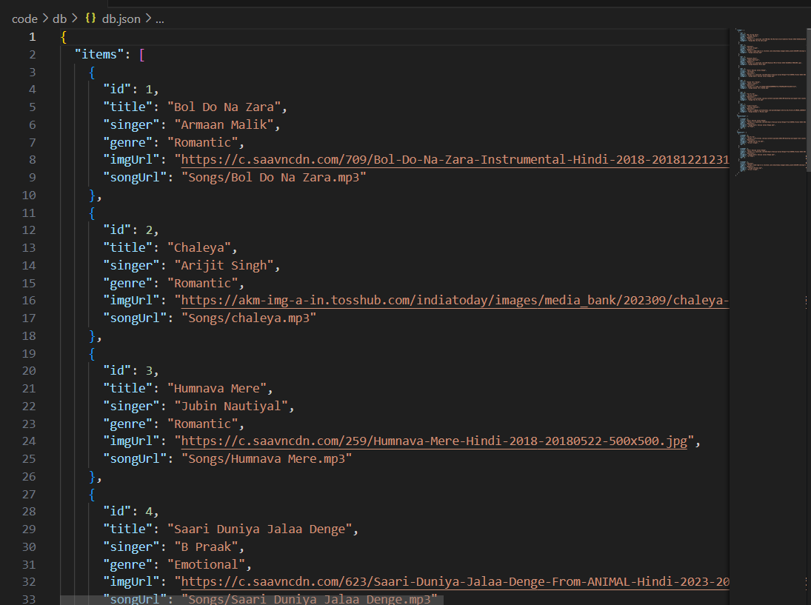

**Screenshot of the output:**

**Figure 1: output opening page**

**Figure 2: favourite page**

**Figure 3: playlist**

**Demo link:**

https://drive.google.com/drive/folders/1RCVswAN37MXyXE_R5SoDtUzSimUhJSlD

**Thank you**